Name _________________________________ Date Due: ___,__,____
Common Core Algebra Regents Review #4
Directions: Choose the best answer. Answer ALL questions. Show ALL work in column 2. If there is no mathematical work to be shown, write an explanation or definition to support your answer!
- Choose the expression that mathematically represents 6 times a number less than 9.
- $9 - 6x$ 3. $6+ y - 9$
- $9-6 + x$ 4. $6x-9$

- From 7x² – 4x subtract 5x² + 2x.

    - 12x² – 2x 3. 2x² + 6x
    - 2x² – 6x 4. 2x² – 2x

- The leading coefficient in the polynomial ${2x}^{3}-{4x}^{5}+6x-9$is

- 2 3. -4
- 6 4. -9

- Which expression is equivalent to 2(3g − 4) − (8g + 3)?
- −2g – 1 3. −2g − 5
- −2g – 7 4. −2g – 11
- The length of a rectangular room is 7 less than three times the width, w, of the room. Which expression represents the area of the room?
- 3w – 4 3. 3w – 7
- 3w²– 4w 4. 3w²– 7w

- Which expression is equal to (x + 3)²?
    - x² + 6 3. x² + 9
    - x² + 6x + 9 4. x² + 3x + 9

- Which expression is an example of the associative property?
    - (x + y) + z = x + (y + z) 3. $x+y=y+x$
    - x(y + z) = xy + xz 4. x • 1 = x
- Solve for x: 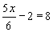
    - 6 3. 8
    - 10 4. 12
- The solution to $-3\left(x-2\right)<-3$ is

  - $x>3$ 3. $x<-3$
  - $x<3$ 4. $x≥-3$
- If x represents the smallest of three consecutive even integers, then the largest would be represented by:
1. $x+4$ 3. $x+6$
2. $x+2$ 4. $x+3$

- Which graph represents the solution set for
$2x-4≤8 and x+5≥7$ ?
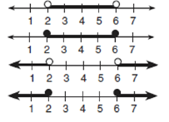
1.
2.
3.

- Which inequality is represented in the graph below?  - y ≥ −3x + 4 3. y ≤ −3x + 4  - y ≥ −4x – 3 4. y ≤ −4x – 3 | 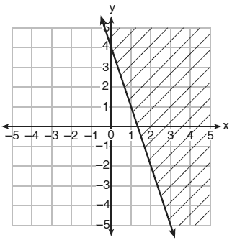
- Which ordered pair is the solution of the following system of equations?
3x + 2y = 4
−2x + 2y = 24
  - (2, −1) 3. (2, −5)
  - (−4, 8) 4. (−4, −8)
- The table below represents the number of hours a student worked and the amount of money the student earned. What equation correctly represents the number of dollars, d, earned in terms of the number of hours, h, worked?  - h = 6.25d 3. d = 6.25h  - h = 50 + 6.25d 4. d = 50 + 6.25h | 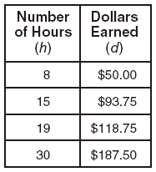
- Find the domain and range for the absolute value function $f\left(x\right)=\left|x-5\right|$ .
  - $D=\left(-∞,∞\right) R=[0,∞)$
  - $D=\left(-∞,∞\right) R=[-5,∞)$
  - $D=\left(-∞,∞\right) R=\left(0,∞\right)$
  - $D=\left(-∞,∞\right) R=(-∞,∞)$
- For which x interval in the function $f\left(x\right)>0$? (positive)  - $-2,<x<∞$  - $1<x<∞$  - $-5<x<1$  - $-5<x<4$ | 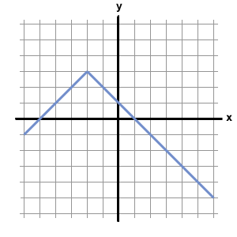
- What effect does decreasing the constant c (c is a real #) by 2 units in an equation of the form y = $x^{2}$ + c have on its graph?

  - Graph shifts left 2 units
  - Graph shifts right 2 units
  - Graph shifts up 2 units
  - Graph shifts down 2 units
- The graph below is the graph of what type of function?  - Linear 3. Step  - Absolute value 4. Quadratic | 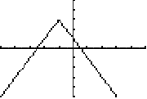
- The graph of y = f(x) is shown below.  Which point could be used to find f(-2)?  - A  - B  - C  - D | 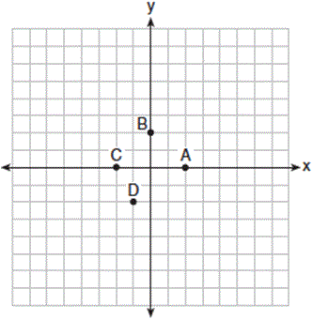
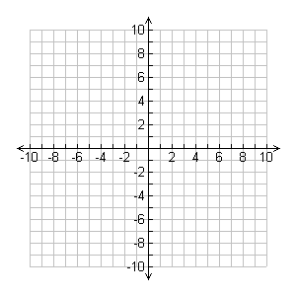
- Graph the following system of inequalities on a set of axes. Which of the following points falls in the solution area of the two inequalities?
$y +x > 2$ $y-5 ≤ \frac{2}{3}x$

  - (–2, 0) 3. (1, 7)
  - (4, 4) 4. (–3, 4)

- Let f be a function such that f(x)= 3x − 2 is defined on the domain 1 ≤ x ≤ 9. The range of this function is
    - 9 ≤ f(x) ≤ 25 3. −∞ ≤ f(x) ≤ ∞
    - 1 ≤ f(x) ≤ 9 4. 1 ≤ f(x) ≤ 25

- Given the table below, what is the average rate of change when $-4˂x˂1$

    - $\frac{1}{5}$ 3. $-\frac{1}{5}$
    - 5 4. -5
- Max was 180 miles away after 2 hours of his trip to his parents’ house, after 6 hours he was 20 miles away from their house. What is Max’s rate of change?

    - -0.025 miles per hour 3. 0.025 miles per hour
    - 40 miles per hour 4. -40 miles per hour
- The owner of a small computer repair business has one employee, who is paid an hourly rate of $22. The owner estimates his weekly profit using the function P(x) = 8600 – 22x. In this function, x represents the number of

- computers repaired per week
- hours worked per week
- customers served per week
- days worked per week
- If f(n) = (n − 1)² + 3n, which statement is true?

- f(3) = −2 3. f(−2) = 3

- f(−15) = −2 4. f(−2) = −15
- The table below represents the function F.
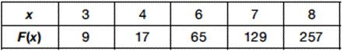
The equation that represents this function is
  - F(x) = 3^{x} 3. F(x) = 3x

  - F(x) = 2^{x} + 1 4. F(x) = 2x + 3
- Nora says that the graph of a circle is a function because she can trace the whole graph without picking up her pencil. Mia says that a circle graph is not a function because multiple values of x map to the same y-value. Determine if either one is correct, and justify your answer completely.

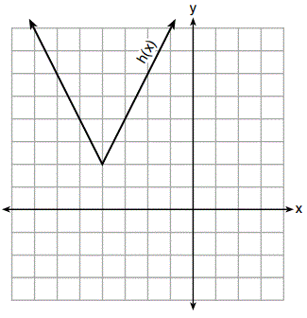
- The function h(x), which is graphed below, and the function g(x) = 2|x + 4| – 3 are given.
Which statements about these functions are true?
I. g(x) has a lower minimum value than h(x).
II. For all values of x, h(x) < g(x).
III. For any value of x, g(x) ≠ h(x).
- I and II, only
- I and III, only
- II and III, only
- I, II, and III

- Which pair of equations could not be used to solve the following equations for x and y?
4x + 2y = 22
–2x + 2y = –8
- 4x + 2y = 22 3. 4x + 2y = 22
2x – 2y =8 –4x + 4y = –16
- 12x + 6y = 66 4. 8x + 4y = 44
6x – 6y = 24 –8x + 8y = –8

- Two friends went to a restaurant and ordered one plain pizza and two sodas. Their bill totaled $15.95. Later that day, five friends went to the same restaurant. They ordered three plain pizzas and each person had one soda. Their bill totaled $45.90. Write and solve a system of equations to determine the price of one plain pizza. [Only an algebraic solution can receive full credit.] (4 points)

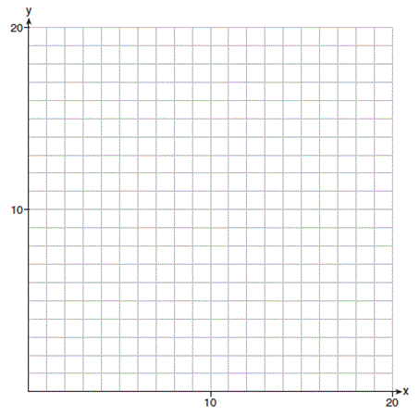
- Edith babysits for x hours a week after school at a job that pays $4 an hour. She has accepted a job that pays $8 an hour as a library assistant working y hours a week. She will work both jobs. She is able to work no more than 15 hours a week, due to school commitments. Edith wants to earn at least $80 a week, working a combination of both jobs.
PART A: Write a system of inequalities that can be used to represent the situation. (2 pt)

PART B: Graph these inequalities on the set of axes below. (4pt)
PART C: Determine and state one combination of hours that will allow Edith to earn at least $80 per week while working no more than 15 hours. (1 pt)

Extra:
- What is the slope of the line that passes through the points (-6,1) and (4,-4)?

- -2 3. 2
- - 4.
- The table below could be used to graph which equation?  - y = –x + 2  - y = x + 2  - y = –x – 2  - y = x – 2 |  | x y  0 2  1 1  –1 3
16. A function is graphed on the axes below. What function is related to the graph?  - 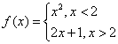 3. 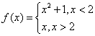  - 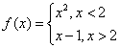 4. 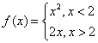 |  | 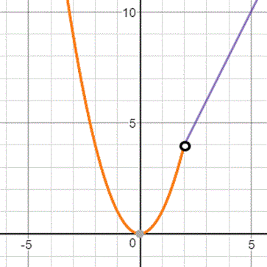
- Maxwell runs 5 miles in 40 minutes, which of the following statements is true:
    - The independent variable is Distance, the dependent variable is Time, and the slope is $\frac{5}{40}$
    - The independent variable is Distance, the dependent variable is Time, and the slope is $\frac{40}{5}$
    - The independent variable is Time, the dependent variable is Distance, and the slope is $\frac{5}{40}$
    - The independent variable is Time, the dependent variable is Distance, and the slope is $\frac{40}{5}$
- Let f be a function such that f(x)= 3x − 2 is defined on the domain 1 ≤ x ≤ 9. The range of this function is
- 9 ≤ f(x) ≤ 25 3. −∞ ≤ f(x) ≤ ∞
- 1 ≤ f(x) ≤ 9 4. 1 ≤ f(x) ≤ 25

- Solve the following system of equations for y:
- 2x + y = 12
- −2x + 3 y = −4
- 8 3. 2
- 3 4. 4
- Given the table below, what is the average rate of change when $-4˂x˂1$

5. Which order pair is not in the solution set of
$$y> \frac{-1}{2}x+5 and y ≤3x-2$$

- ( 5, 3 ) 2) (4, 3)
- (3, 4) 4) (4, 4)
6. Which point is on the graph represented by
$$f(x)= x^{2}+3x+6$$

(1) (-6,12) (3) (2,16)
(2) (-4,4) (4) (3,-6)
7. The value of the x-intercept for the graph of
$4x - 5y = 40$ is

(1) 10 (3) -4/5

(2) 4/5 (4) -8

8. The formula for the area of a trapezoid is
$A= \frac{1}{2}h(b1+$ b2).

Express b1 in terms of A, h, and$b_{2}$.
9. Evaluate each of the following: (2 Points)  $$f\left(-3\right)= f\left(1\right)= f\left(3\right)=$$  $$f\left(1\right)+f\left(-3\right)=$$ | 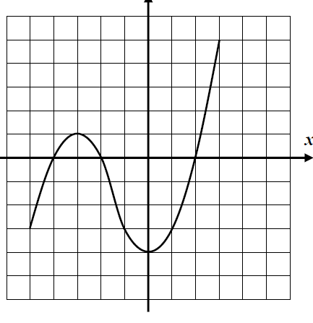
10. What is the domain of over the set of real numbers?
- {x | x ≤ 4}
- {x | x ≥ 4}
- {x | x > 4}
- {x | x = 4}
11. What is an equation of the line that passes through the points (2, 1) and (6, −5)?
- y = −​x − 2
- y = −​x + 4
- y = −​x − 1​
- y = −​x +

12. The graph below shows the average price of gasoline, in dollars, for the years 1997 to 2007.  What is the approximate range of this graph?  - 1997 ≤ x ≤ 2007  - 1999 ≤ x ≤ 2007  - 0.97 ≤ y ≤​ 2.38  - 1.27 ≤ y ≤ 2.38 | 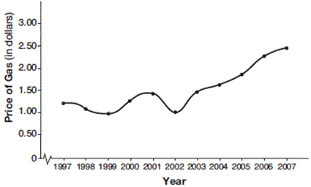
13. Which value of x is the solution of the equation
$2(x - 4) + 7 = 3$?
- 1 2. 2
- 6 4. 0
14. A company that manufactures radios first pays a start-up cost, and then spends a certain amount of money to manufacture each radio. If the cost of manufacturing r radios is given by the function c(r) = 5.25r + 125, then the value 5.25 best represents
- the start-up cost
- the profit earned from the sale of one radio
- the amount spent to manufacture each radio
- the average number of radios manufactured
15. The graph below shows the variation in the average temperature of Earth’s surface from 1950–2000, according to one source.  During which years did the temperature variation change the most per unit time? Explain how you determined your answer. | 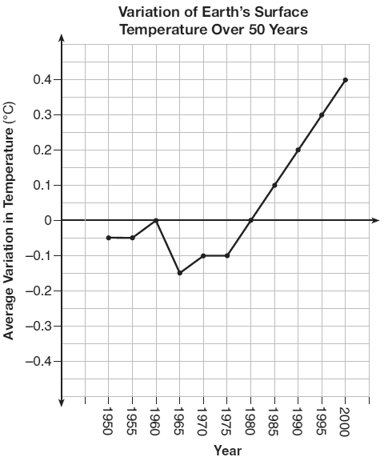
16. Which graph below shows the effect of decreasing the value of c in the function y = x² – 2?
- 1. 2. 3.4.

- a. On the set of axes, graph the function represented by $g(x)= \sqrt[3]{x-2}$  and provide a table of values.  b. Graph $h\left(x\right)=g\left(x-3\right)$  c. Describe the Transformation (4 points) | 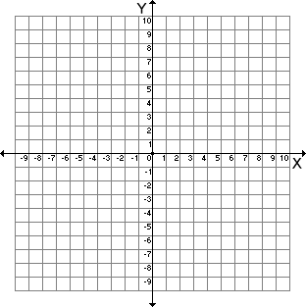
3.When solving the equation
$4\left(3x^{2}+2\right)-9=8x^{2}+7$ , Amy wrote:
$4\left(3x^{2}+2\right)=8x^{2}+16$ as her first step.
Which property justifies Amy’s first step?
(1) addition property of equality
(2) commutative property of addition
(3) multiplication property of equality
(4) distributive property of multiplication over addition

Bonus: A satellite television company charges a one-time installation fee and a monthly service charge. The total cost is modeled by the function y = 40 + 90x. Which statement represents the meaning of each part of the function?
- y is the total cost, x is the number of months of service, $90 is the installation fee, and $40 is the service charge per month.
- y is the total cost, x is the number of months of service, $40 is the installation fee, and $90 is the service charge per month.
- x is the total cost, y is the number of months of service, $40 is the installation fee, and $90 is the service charge per month.
- x is the total cost, y is the number of months of service, $90 is the installation fee, and $40 is the service charge per month.

